**React Native CLI Setup Documentation**

**Introduction: -**

React Native is an open-source framework that enables cross-platform mobile application building using JavaScript and react developed by Facebook and other developers to build user interfaces.

React Native uses JSX to create native apps for Android and iOS.

It is a cross platform compatible framework that means you can develop one app for any platform like windows, android, iOS and web. It is released in Jan 2015.

**Software Requirements: -**

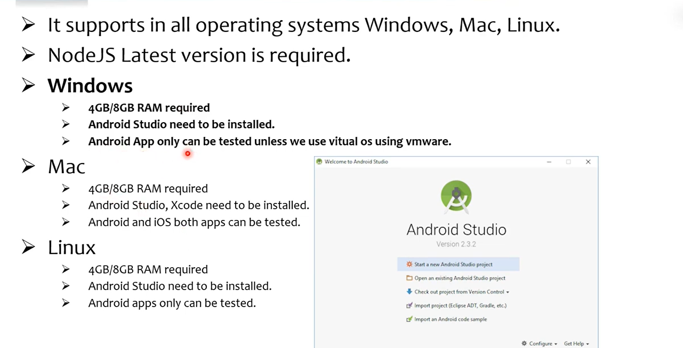

It supports in all operating systems Windows, Mac, Linux.

NodeJS Latest version is required.

**Expo vs React Native CLI**

* We have two ways to develop react native apps.
* Expo or React Native CLI
* Expo and React Native both are command line interface libraries.
* You can use Expo, if you are a complete beginner. It takes only minutes.
* You can use React Native CLI, if you are already installed Android Studio / Xcode etc>, which takes few hours to setup.

**Environment Setup with Expo**

* **Install Expo CLI:**

**npm install -g expo-cli OR yarn global add expo-cli**

* **Create Project:**

**Expo init Project Name**

* **Run the app:**

**Cd ProjectName && npm start OR expo start**

* **Choose platform (a-Android, i-iOS, w-web etc.,)**

**Setup new project in our folder:**

Here to set the React Native with expo following steps

Step1: To open command prompt after run this command in the command prompt

**npm install -g expo-cli OR yarn global add expo-cli**

Step2: After we need to run another command in the same prompt. We give project name and also choose blank option

**Expo init Project Name**

Step3: Next we open our project with in vs code and run the project also.

**Cd ProjectName && npm start OR expo start**

**Prerequisites: -**

1. Node.js - JavaScript runtime environment.
2. React Native CLI - Command-line interface for React Native development.
3. Android Studio - IDE for Android development (includes Android SDK and Emulator).
4. JDK 11 - Java Development Kit for Android.
5. Xcode (macOS only) - IDE for iOS development.
6. Cocoa Pods (macOS only) - Dependency manager for iOS.
7. Android Emulator - For testing Android apps.
   1. **Install Node.js**

• **Download and install** the latest version of **Node.js** from the official [Node.js website](https://nodejs.org/).

* 1. **Install Watchman** (macOS only)

For macOS, you can install Watchman using Homebrew:

**brew install watchman**

* 1. **Install Java Development Kit (JDK)**

React Native requires **JDK 11** or later.

1. **Download and install JDK 11** from [AdoptOpenJDK](https://adoptopenjdk.net/).
2. Set the **JAVA_HOME** environment variable:
   1. **Install Android Studio**

For Android development, you will need **Android Studio**.

1. **Download and install Android Studio** from the official [Android Developer website](https://developer.android.com/studio).
2. In **Android Studio**, open the **SDK Manager** and install:
   * Android SDK
   * Android Emulator
   * Android platform tools
3. **Set up Android environment variables**:
   * For **macOS/Linux**:

bash

Copy code

export ANDROID_HOME=$HOME/Library/Android/sdk

export PATH=$ANDROID_HOME/tools:$ANDROID_HOME/platform-tools:$PATH

* + For **Windows**: Set the ANDROID_HOME environment variable pointing to C:\Users\<YourUsername>\AppData\Local\Android\Sdk.

**1.5 Install Xcode (macOS only)**

For **iOS** development, you need **Xcode** (only on macOS). You can download it from the **Mac App Store**.

**2. Install React Native CLI**

**2.1 Install React Native CLI Globally**

Install the **React Native CLI** using **npm**:

**npm install -g react-native-cli**

**2.2 Verify Installation**

Check if React Native CLI is installed:

**react-native –version**

**3. Create a New React Native Project**

**3.1 Initialize the Project**

Use the npx command to initialize a new React Native project:

**npx react-native init YourProjectName**

1. **Run Your App on Android/iOS**

**4.1 Run the App on Android Emulator**

1. Open Android Studio and start the Android Emulator.
2. In the terminal, run the following command:

**npx react-native run-android**